Django Forms
Django forms provide a powerful framework for handling user input, automating the generation of HTML forms, data validation, and secure processing.
Django provides 3 types of forms
- Standard form
- Model form
- Formset

Form is server side program, and executed and render at server side.
For working with form django is provided a module called “forms”
django.forms

Standard form
A form which does not build using model fields or model is called standard form or generic form. In this form every field is defined by programmer or developer.

Basic steps for developing standard form
- Create form (OR) develop form
- Create object of form
- Render form object within template (HTML)

Create form
Standard form is created or developed by inheriting Form class

Syntax:
class form-class-name(Form):
field-name=type
field-name=type
filed-name=type

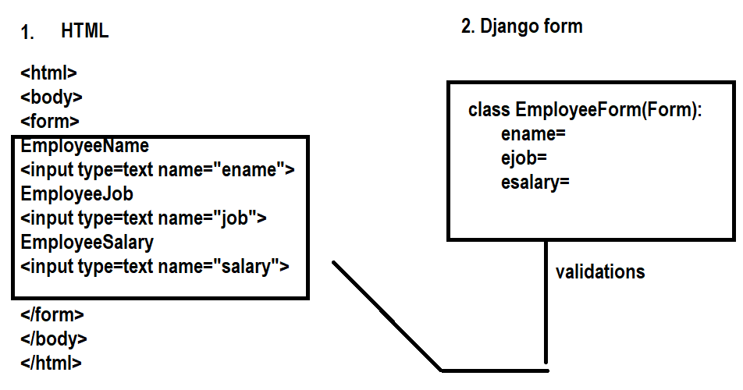

PS D:\Backup\Django9amMar> django-admin startproject project12
PS D:\Backup\Django9amMar> cd project12
PS D:\Backup\Django9amMar\project12> python manage.py startapp app
PS D:\Backup\Django9amMar\project12>

Inside application folder create a module with name forms.py

from django import forms
courses=["python","java","oracle","ai"]
class StudentForm(forms.Form):
rollno=forms.IntegerField(label="StudentRollno")
sname=forms.CharField(max_length=20,min_length=1,label="StudentName")
course=forms.CharField(max_length=20,label="StudentCourse")
fee=forms.FloatField()

views.py
from django.shortcuts import render
from app.forms import StudentForm
# Create your views here.
def stud(request):
stud_form=StudentForm()
response=render(request,"student_temp.html",context={'stud_form':stud_form})
return response

def stud1(request):
stud_form=StudentForm()
response=render(request,"student_temp1.html",context={'stud_form':stud_form})
return response

student_temp.html
<!DOCTYPE html>
<html lang="en">
<head>
<meta charset="UTF-8">
<meta name="viewport" content="width=device-width, initial-scale=1.0">
<title>Document</title>
</head>
<body>
<form>

{{stud_form.as_ul}}

</form>
</body>
</html>

Student_temp1.html
<!DOCTYPE html>
<html lang="en">
<head>
<meta charset="UTF-8">
<meta name="viewport" content="width=device-width, initial-scale=1.0">
<title>Document</title>
</head>
<body>
<form>
<table border="2">
<tr>
<td>{{stud_form.rollno.label}}</td>
<td>{{stud_form.rollno}}</td>
</tr>
<tr>
<td>{{stud_form.sname.label}}</td>
<td>{{stud_form.sname}}</td>
</tr>
</table>
</form>
</body>
</html>

Urls.py
from django.contrib import admin
from django.urls import path
from app.views import stud,stud1
urlpatterns = [
path('admin/', admin.site.urls),
path('stud/',stud),
path('stud1/',stud1),
]

Settings.py
INSTALLED_APPS = [
'django.contrib.admin',
'django.contrib.auth',
'django.contrib.contenttypes',
'django.contrib.sessions',
'django.contrib.messages',
'django.contrib.staticfiles',
'app',
]

TEMPLATES = [
{
'BACKEND': 'django.template.backends.django.DjangoTemplates',
'DIRS': [BASE_DIR/"templates"],
'APP_DIRS': True,
'OPTIONS': {

Form object is render within template in different formats
- as_table
- as_ul
- as_p

{{form-object.as_table}} 🡪 This insert or render form elements as table
{{form-object.as_p}} 🡪 This insert or render form elements as paragraph
{{form-object.as_ul}} 🡪 This insert or render form elements as unorder list

User can customize this organization using form fields

{{form-object.field-name}} 🡪 insert field
{{form-object.field-name.label}} 🡪 insert label

How to validate form data?
A form validation is done populating data within form (OR) storing data within form.
Validation is a process of identifying input data is valid or not

Form validations are done at 2 levels
- field level validation
- form level validation

field level validation
field level validation is done for individual fields.
This validation is done in different ways
- using field attributes
- using validation method or clean methods
- using validators

using field attributes
every fields provided a built in attributes or properties
- max_length
- min_length
- required

forms.py
from django import forms
class StudentForm(forms.Form):
rollno=forms.IntegerField(label="StudentRollno",required=True)
sname=forms.CharField(max_length=20,min_length=3,label="StudentName")
course=forms.CharField(max_length=20,label="StudentCourse")
fee=forms.FloatField()

student_temp.html
<!DOCTYPE html>
<html lang="en">
<head>
<meta charset="UTF-8">
<meta name="viewport" content="width=device-width, initial-scale=1.0">
<title>Document</title>
</head>
<body>
<form method="post">
{%csrf_token%}
<table border="2" width="100%">
{{stud_form.as_table}}
<tr>
<td><input type="submit" value="submit"></td>
</tr>
</form>
</table>
</body>
</html>

Views.py
from django.shortcuts import render
from django.http import HttpResponse
from app.forms import StudentForm
# Create your views here.
def stud(request):
if request.method=="GET":
stud_form=StudentForm()
response=render(request,"student_temp.html",context={'stud_form':stud_form})
return response
else:
stud_form=StudentForm(request.POST)
if stud_form.is_valid():
data=stud_form.cleaned_data
stud=f"{data['rollno'],data['sname']}"
response=HttpResponse(stud)
return response
else:
return HttpResponse("Invalid data")

inside the view, create form by storing input data
stud_form=StudentForm(request.POST)
invoke validation methods by called is_valid() method of form object
this returns Boolean value(True/False)
if is valid_method is True, it return cleaned data inside one dictionary of form object. The dictionary name is clearn_data
data=stud_form.cleaned_data

field attribute or properties validation are HTML validations and these validations are checked client side.

